**SNOWFLAKE TASK2**

**Name : Adviteeya Shrav**

1. Remove all the files from data directory of S3 bucket.

Remove all the files from the old bucket.

Remove the bucket and created new bucket. Name: bootcamp11

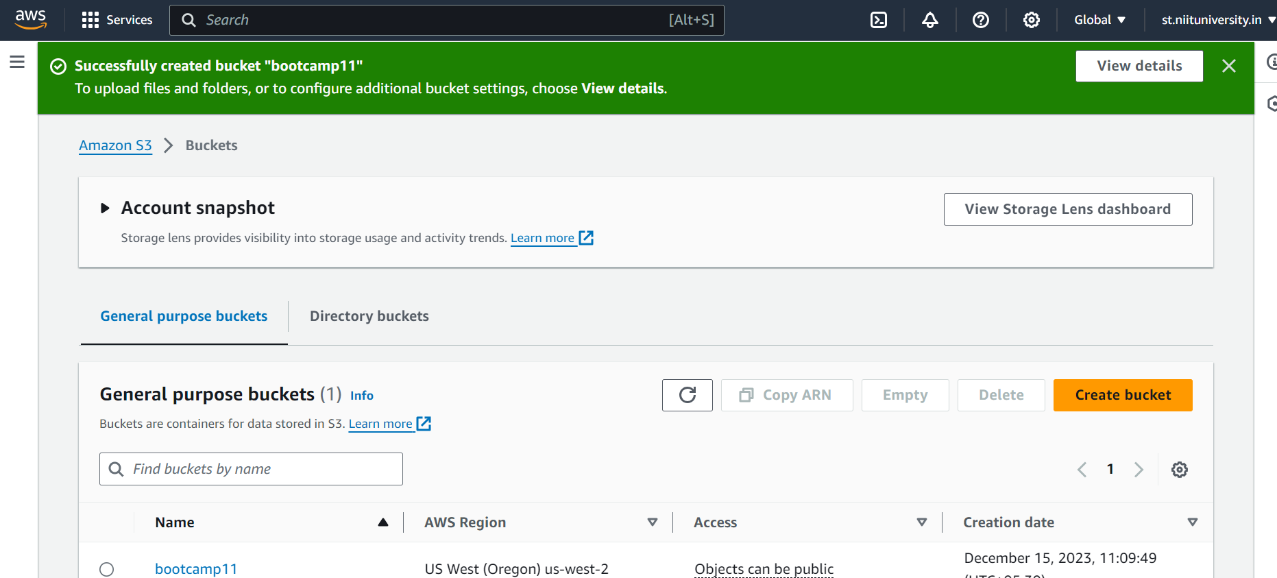

1. Create 3 tables EMP, DEPT, and SALGRADE mapping to the S3 bucket, such that data must be automatically loaded into the tables.

CREATE OR REPLACE STAGE bootcamp11_stage

URL='s3://bootcamp11/data/'CREDENTIALS=(AWS_KEY_ID=' xxxxxxxxxxxxxxxxxxxxX' AWS_SECRET_KEY='xxxxxxxxxxxxxxxxxxxxxxxxxX’)

1. Load the files accordingly and check the data.

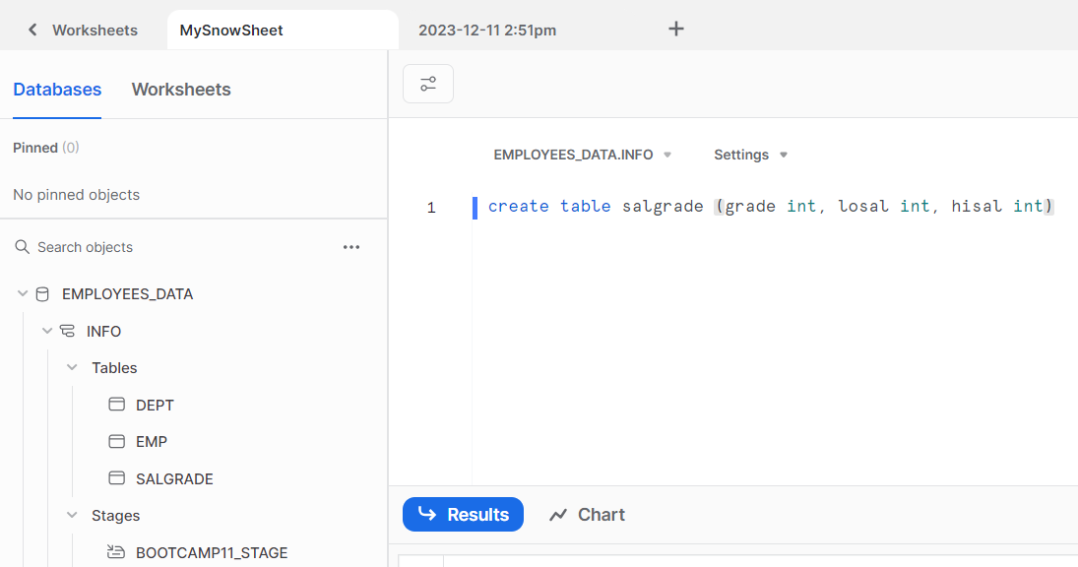

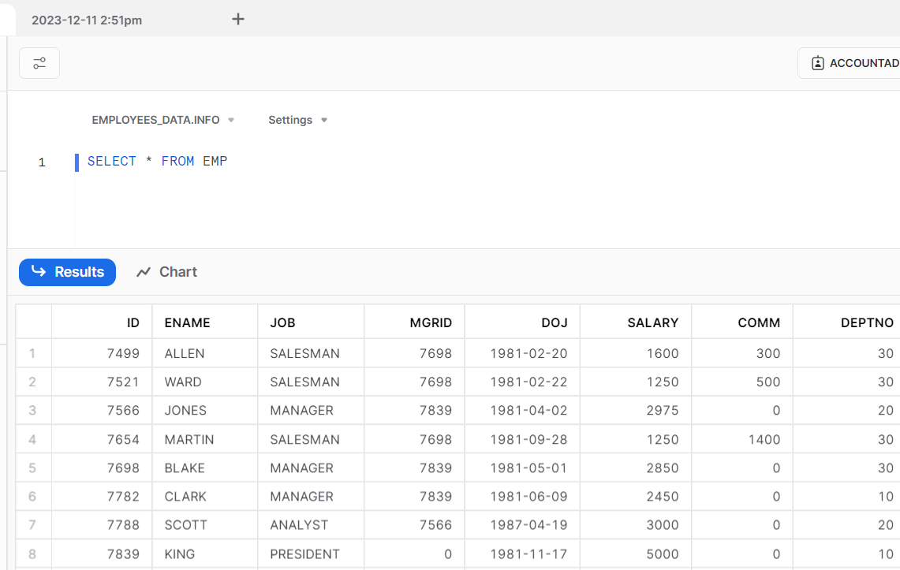

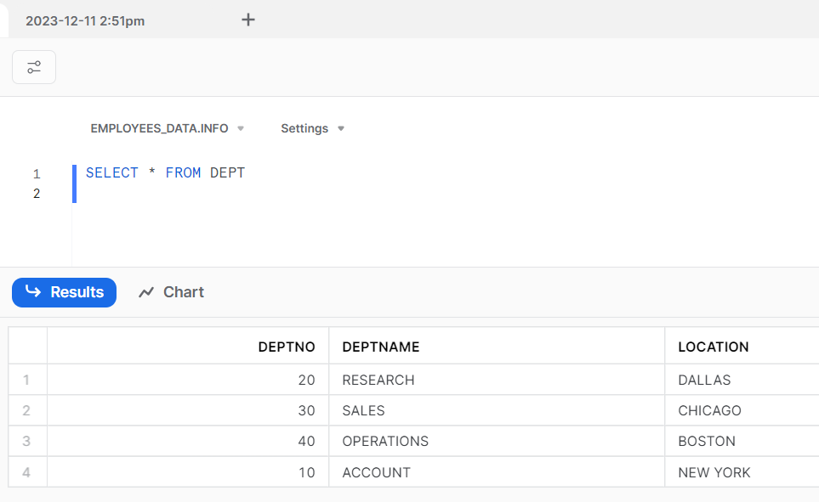

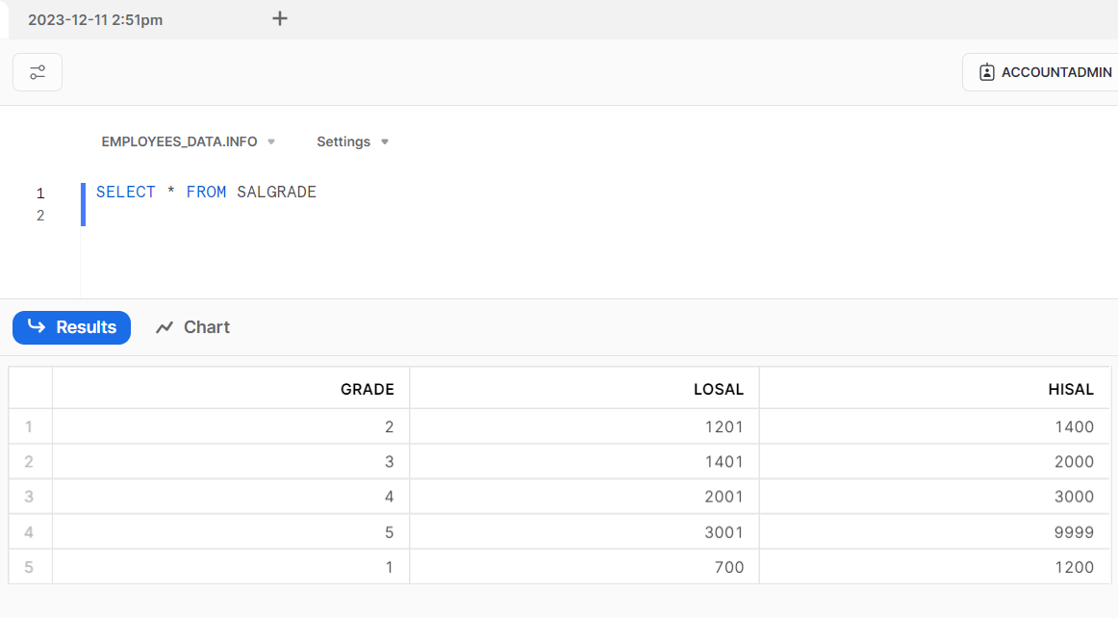

1. Perform the below queries:
2. Find out the department not allotted to any employee.

SELECT * FROM DEPT WHERE DEPTNO NOT IN (SELECT DEPTNO FROM EMP)

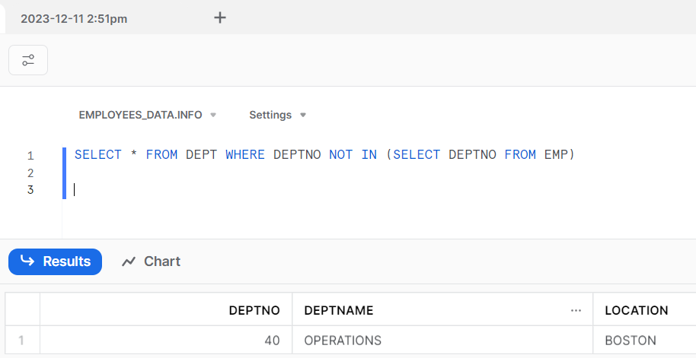

1. Find the employees with highest salary in each department.

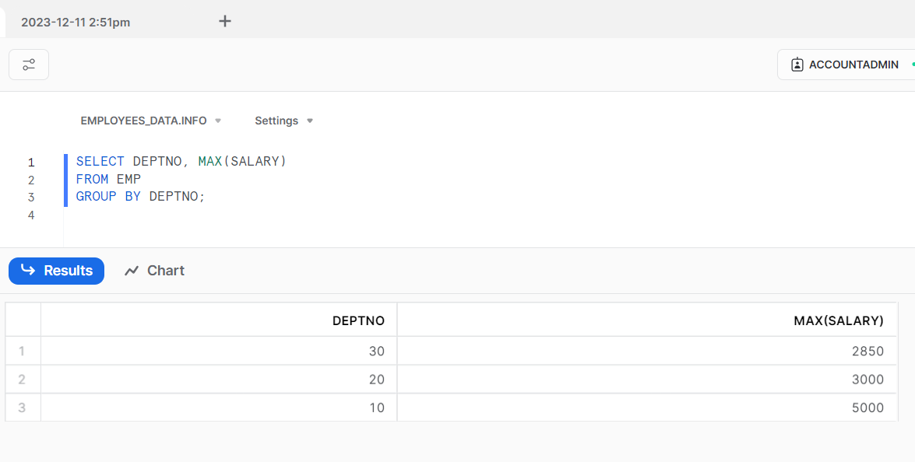

1. Find out how many employees are there in each department who are not earning any commission.

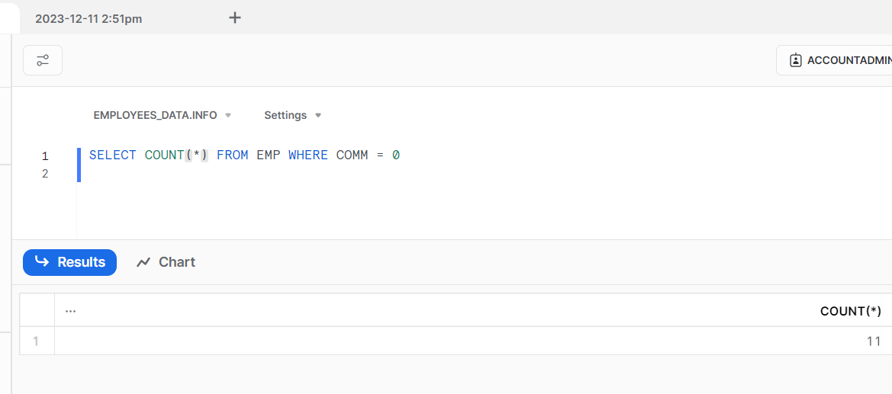

1. Print the employee names, their department names, and their salary grades.

